Summary:
In this exercise you’ll use Interference Detection and Collision Detection to identify issues in an assembly. Using this information you’ll edit the components in the assembly to eliminate the interference and collision.
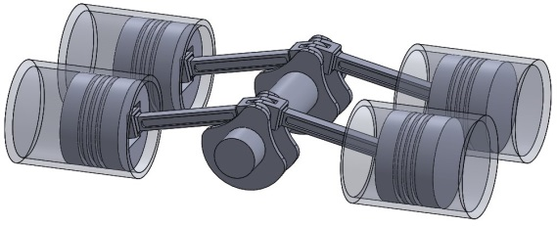
Reference Lessons:
- Interference Detection
- Collision Detection

Instructions:
- Download and unzip the components here.

- Open the “4 Cylinder Crankshaft.SLDASM” assembly in SOLIDWORKS.
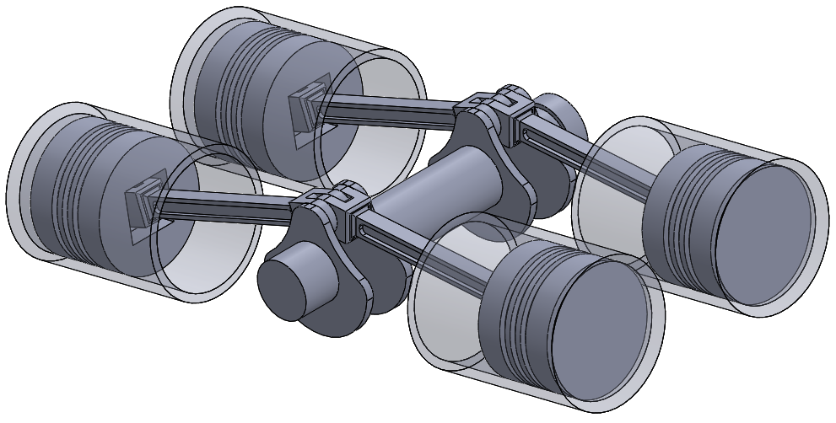

- Use Interference and Collision Detection to identify components that need to be edited in order to finalize the assembly.

- Edit the Rod component and
  - Edit the rod and reduce the overall width of the joints to 37.5 mm so the gap is equal in size to the each of the teeth.
  - Reduce the length of the rod to 125 mm.

Final Result:
If you completed the exercise successfully, your result should look like the image shown below:
